***SISTEMA DE SETAS E PISCA ALERTA ( programação com o if e três variáveis)***

Foto do projeto:

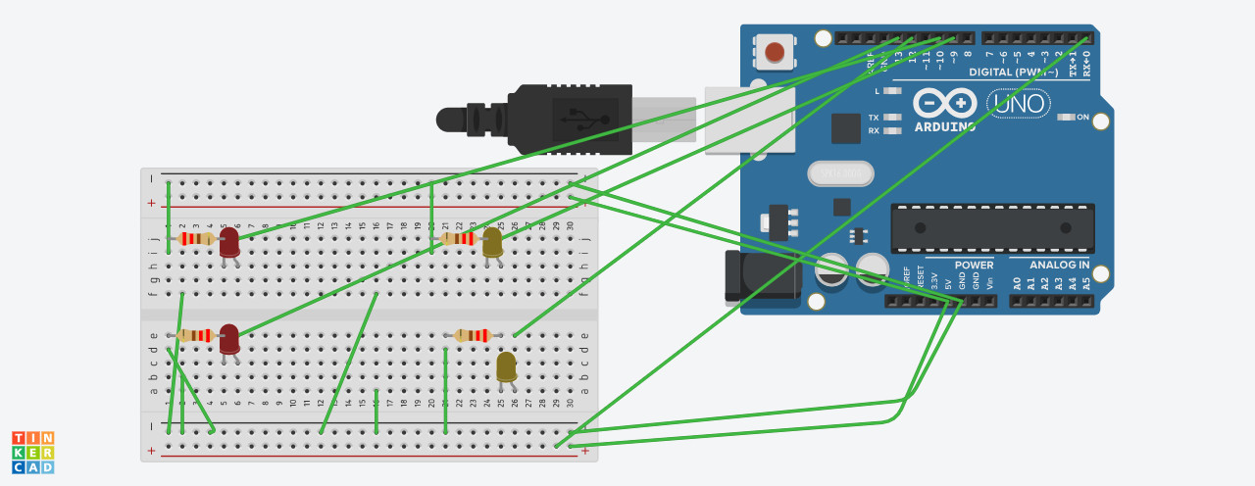

Programação:

const int btn1 = 0;

const int btn2 = 1;

const int btn3 = 2;

int cond1 = 0;

int cond2 = 1;

int cond3 = 2;

void setup()

{

pinMode(13, OUTPUT);

pinMode(12, OUTPUT);

pinMode(11, OUTPUT);

pinMode(10, OUTPUT);

pinMode(btn1,INPUT);

}

void loop()

{

cond1 = digitalRead(btn1);

cond2 = digitalRead(btn2);

cond3 = digitalRead(btn3);

if (cond1== HIGH && cond2 == LOW && cond3 == LOW) {

digitalWrite(13, HIGH);

digitalWrite(12, LOW);

digitalWrite(11, HIGH);

digitalWrite(10, LOW);

delay(1000);

digitalWrite(13, LOW);

digitalWrite(12, HIGH);

digitalWrite(11, LOW);

digitalWrite(10, HIGH);

delay(1000);

digitalWrite(13, HIGH);

digitalWrite(12, HIGH);

digitalWrite(11, HIGH);

digitalWrite(10, HIGH);

delay(1000);

digitalWrite(13, LOW);

digitalWrite(12, LOW);

digitalWrite(11, LOW);

digitalWrite(10, LOW);

delay(1000);

digitalWrite(13, HIGH);

digitalWrite(12, HIGH);

digitalWrite(11, HIGH);

digitalWrite(10, HIGH);

delay(1000);

digitalWrite(13, LOW);

digitalWrite(12, LOW);

digitalWrite(11, LOW);

digitalWrite(10, LOW);

delay(1000);

}

}